**Django Internship Report**

**Personal Details**

Name : Nishant Movaliya

College Name : Government Engineering College,Modasa

Degree : BE

Semester : 7

Github URL : <https://github.com/nishantmovaliya>

**Company Details**

Company Name : Akash Technolabs

External Guide : Akash Padhiyar

Training Duration : 26-05-2021 to 14-06-2021

**Index**

# 

|  |  |  |
| --- | --- | --- |
| **Index** | **Task Detail** | **Page Name** |
| 1 | Basic HTML based : To Create Registration form using div/table. | 3 |
| 2 | Write Basic Python Programs which is run in lecture. | 5 |
| 3 | Complete the Task Sent by Ma’am (15 Examples) | 8 |
| 4 | 1.List All the Operators 2.Functions and Modules | 11 |
| 5 | Solve the Tasks Sent by Ma’am: (OOP-Python) | 15 |
| 6 | Install Django, Run and Display Browser Window | 19 |
| 7 | Display Hello World Text in Browser in Django | 21 |
| 8 | Template Integration and URL Routing | 23 |
| 9 | Using POST method to get User Values and returning back on page. | 26 |
| 10 | Implementing Models and Fetching Values using  Function Based Views and Class Based Views | 29 |

**Task-1**

**Basic HTML based : To Create Registration form using div/table.**

**registration_form.html**

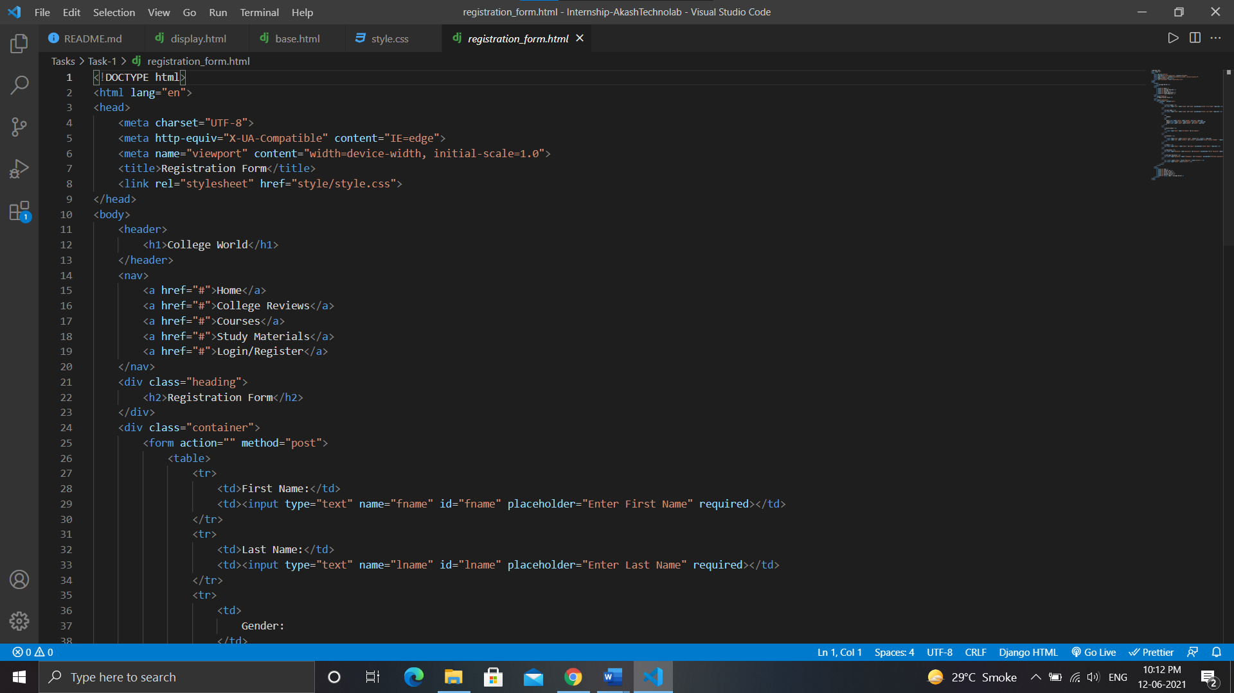

**style.css**

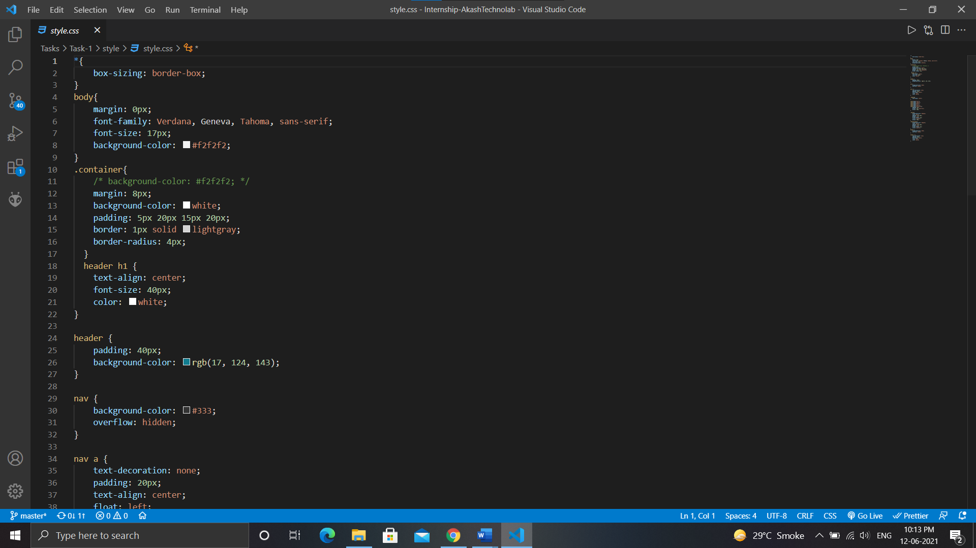

**Output:**

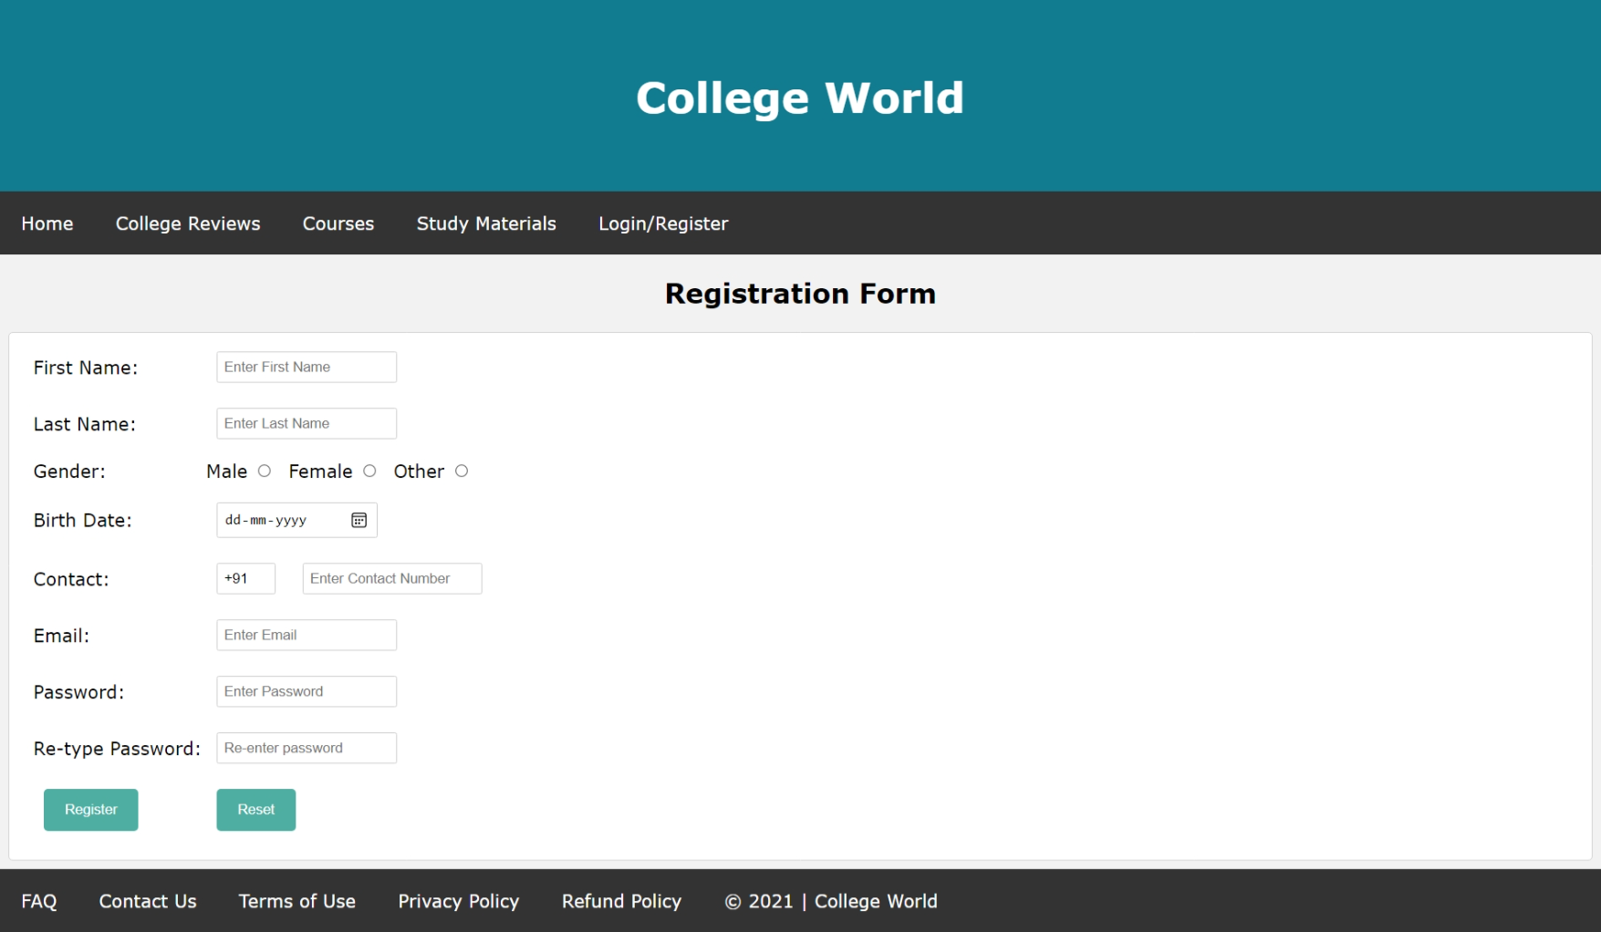

**Task-2**

**Task:** Write Basic Python Programs which is run in lecture.

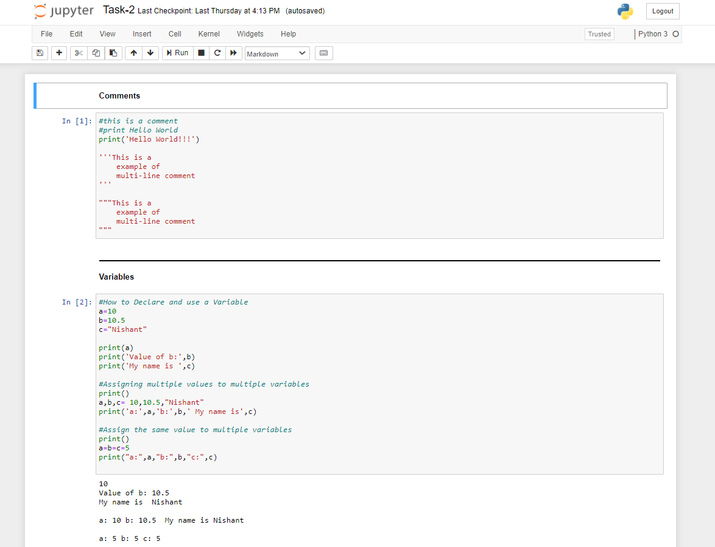

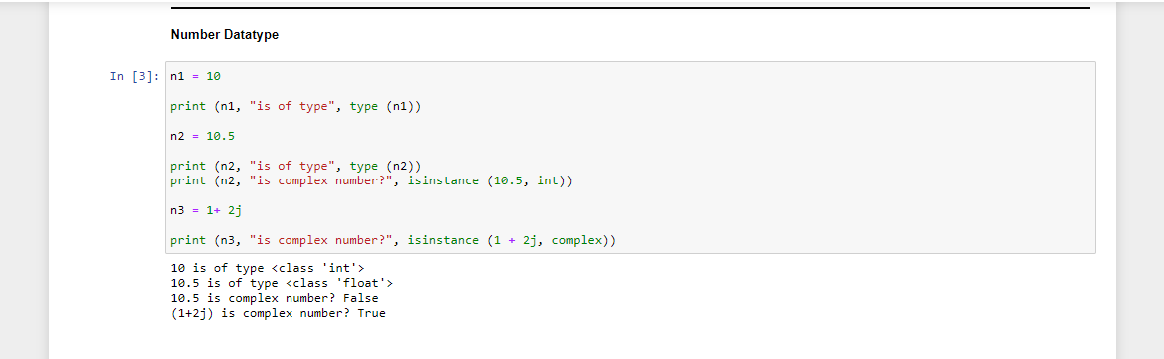

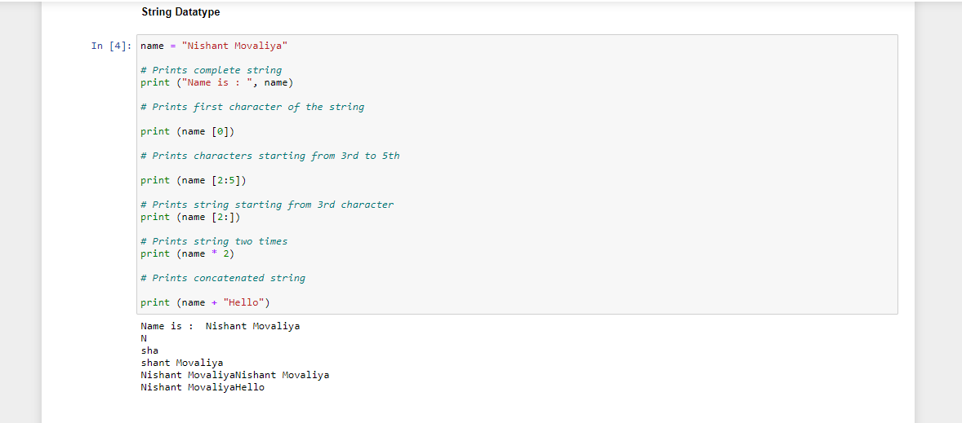

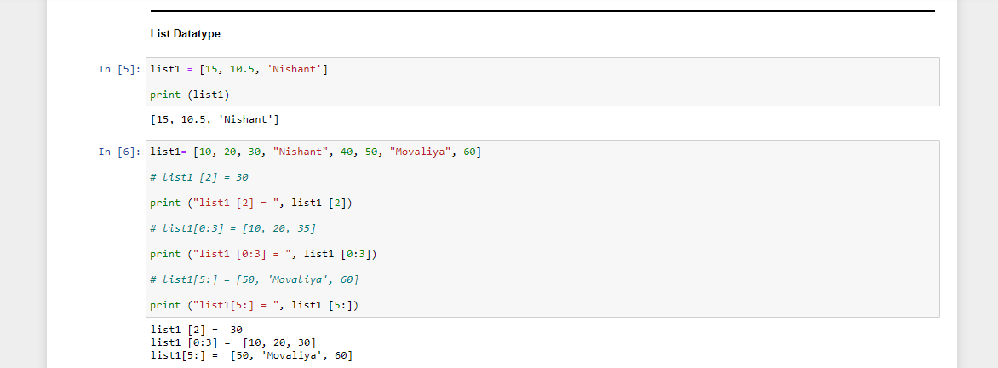

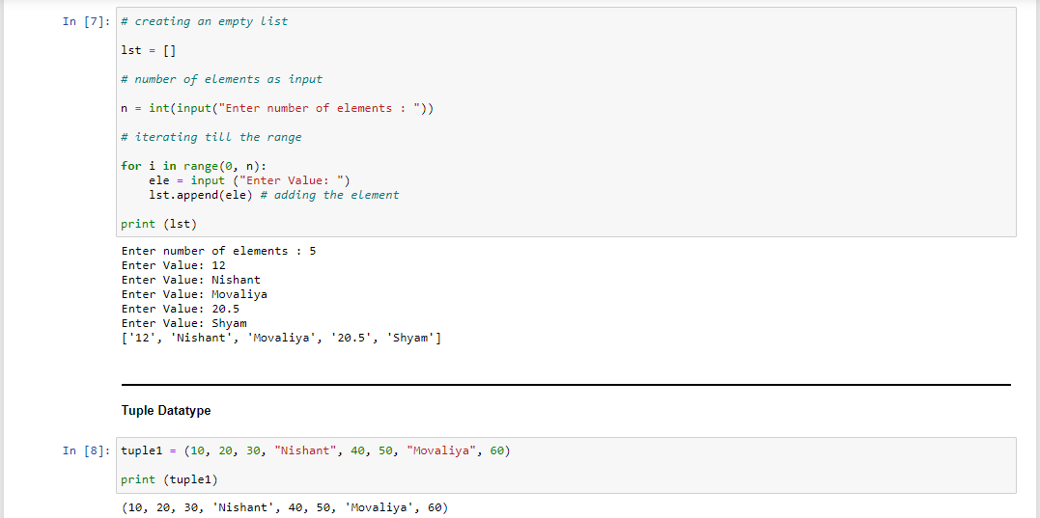

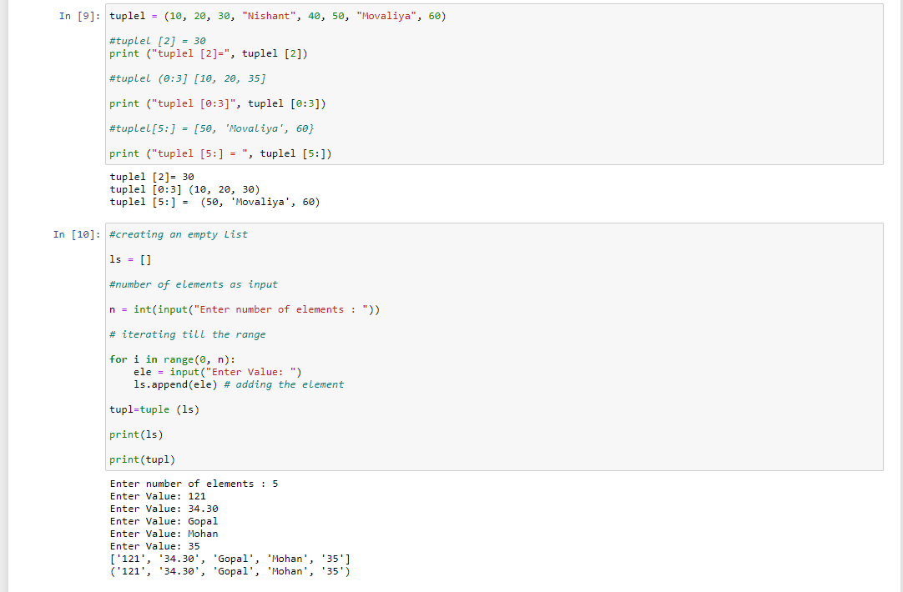

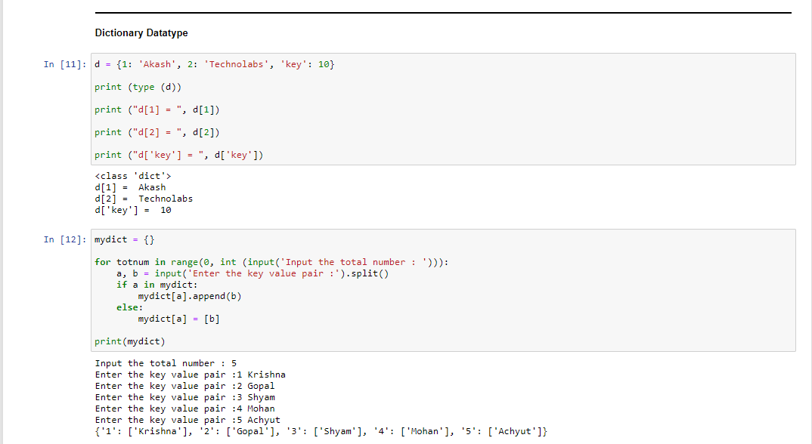

**Task-3:**

**Task:** Complete the Task Sent by Ma’am (15 Examples)

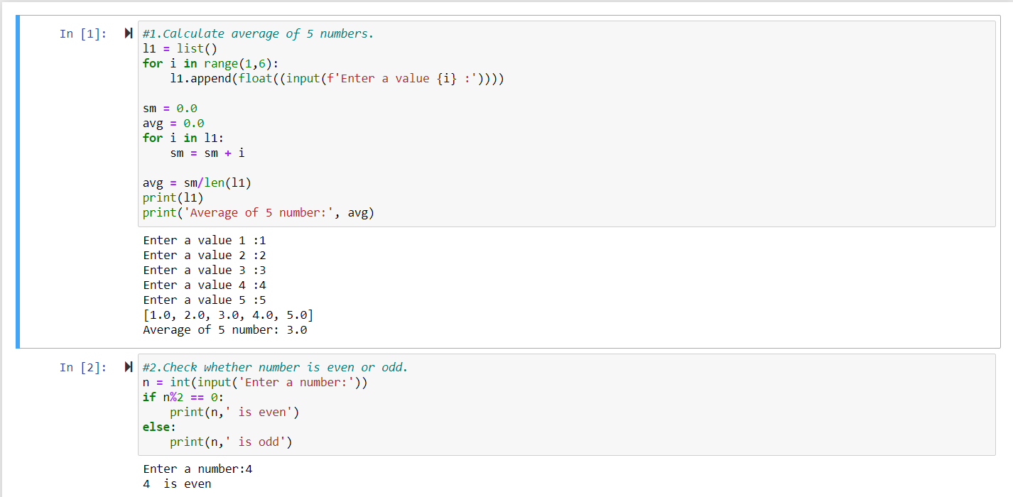

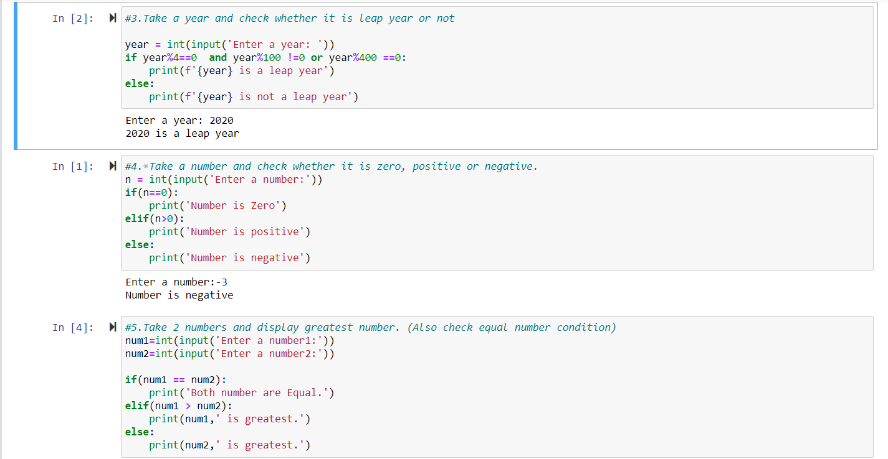

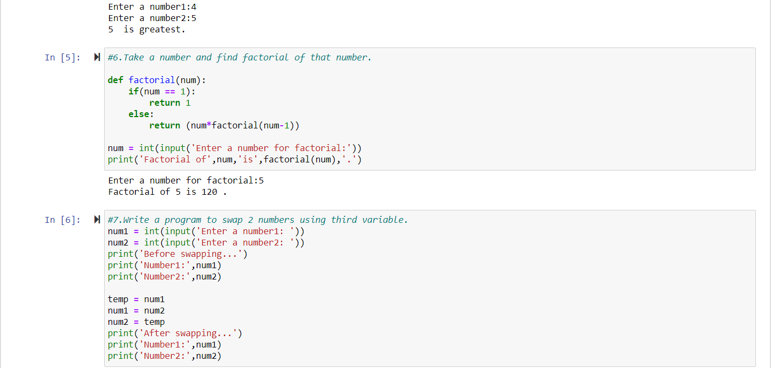

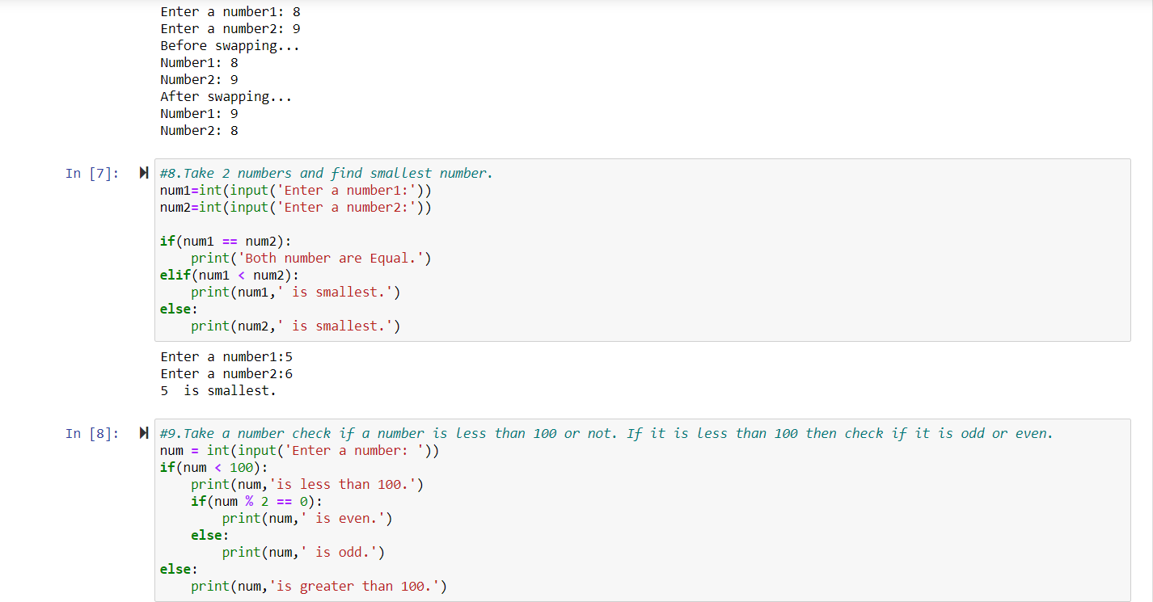

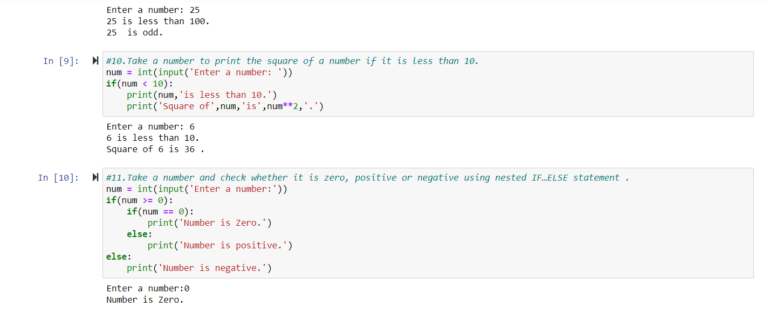

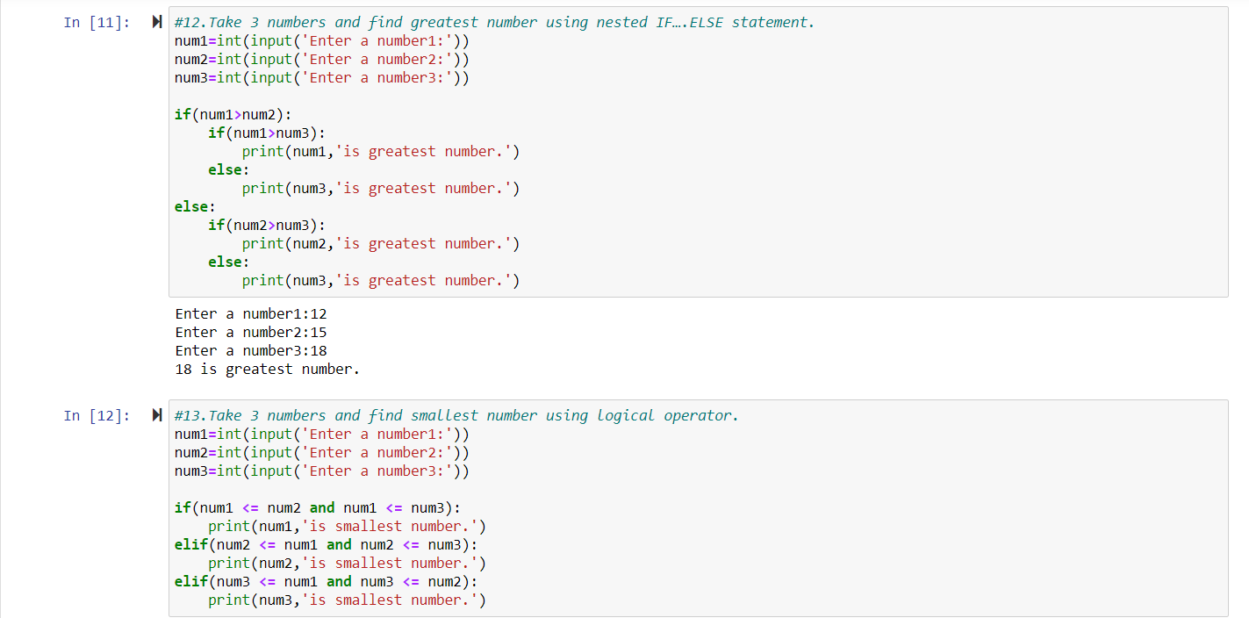

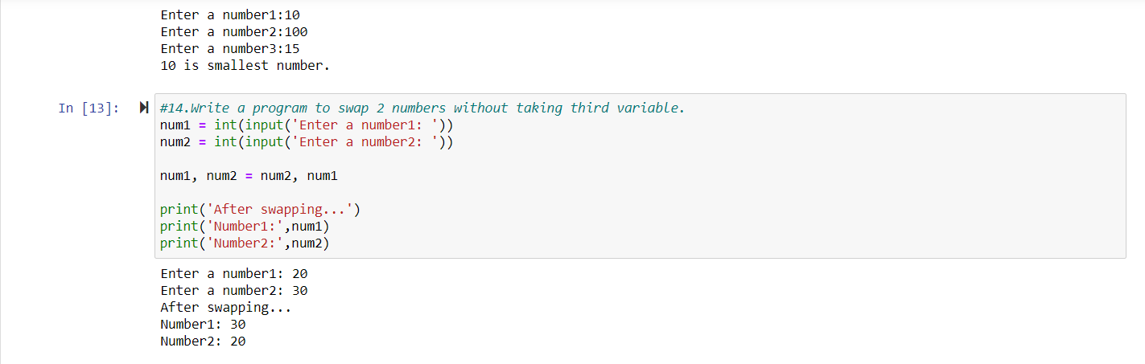

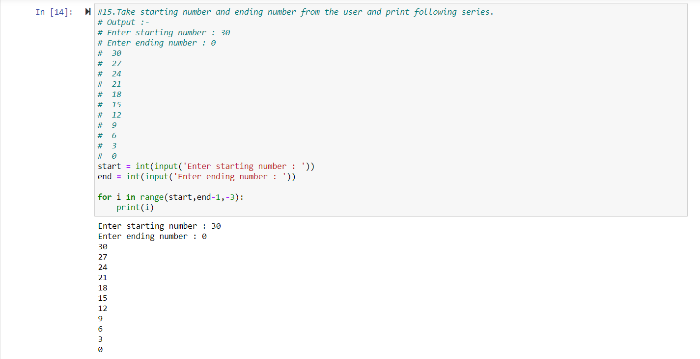

**Task-4**

**Task:** 1.List All the Operators 2.Functions and Modules

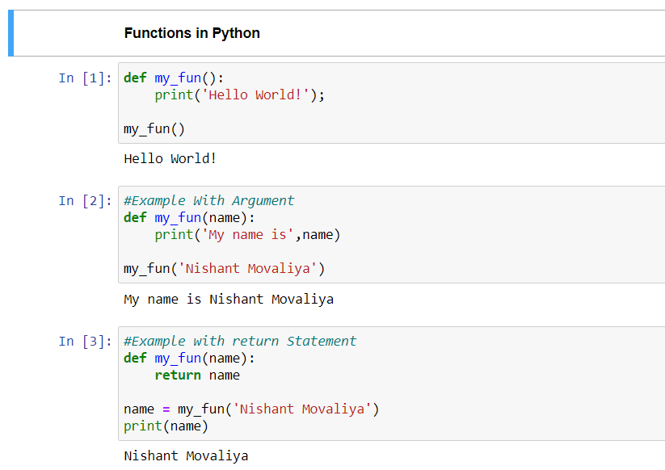

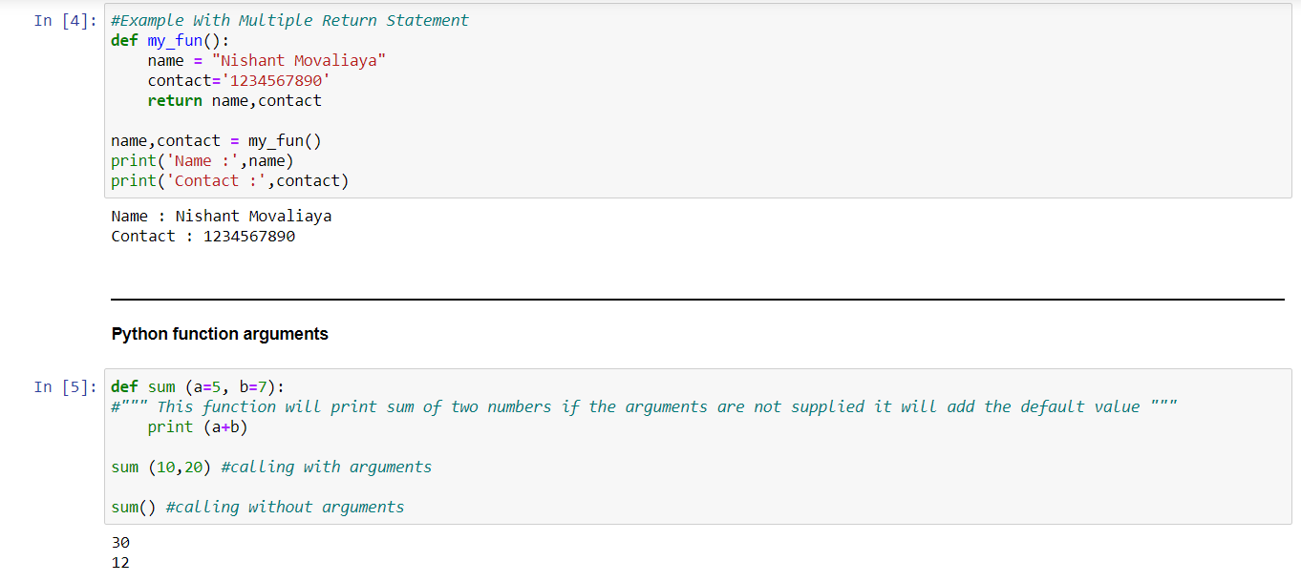

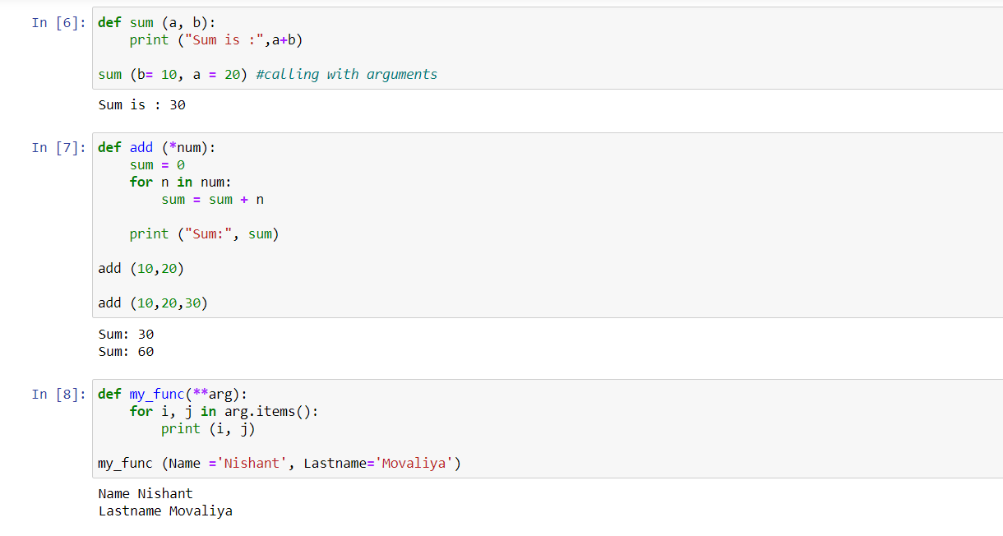

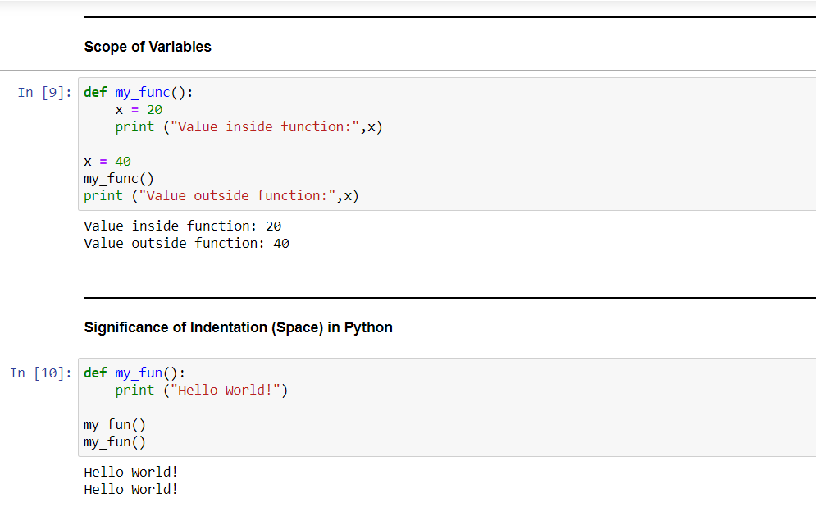

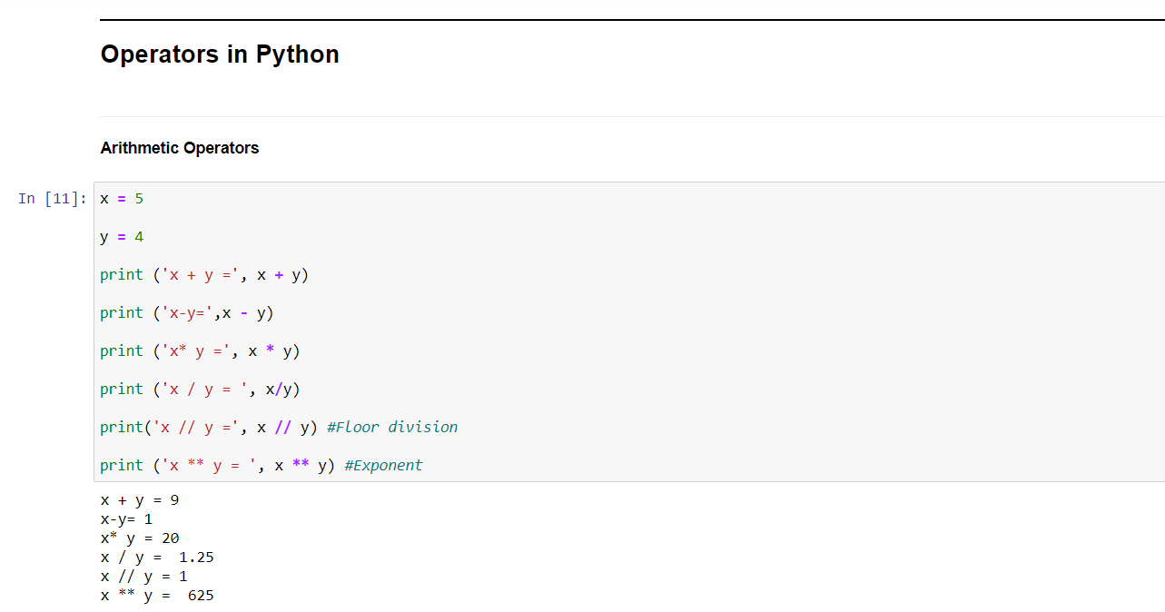

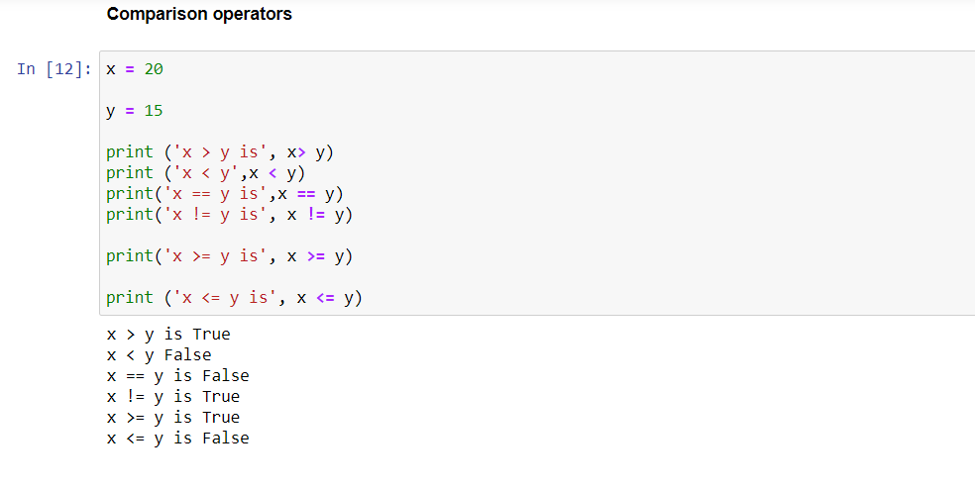

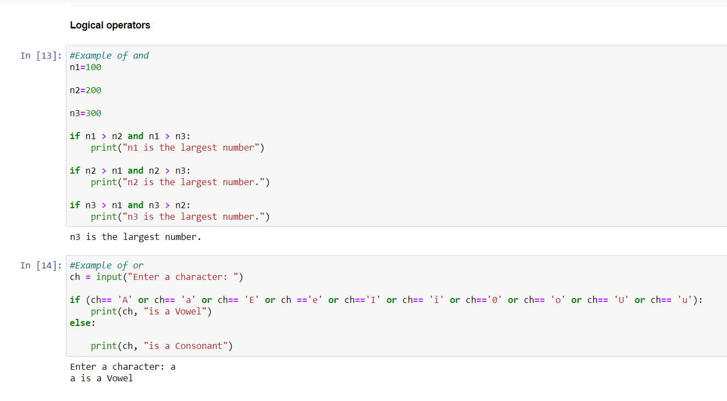

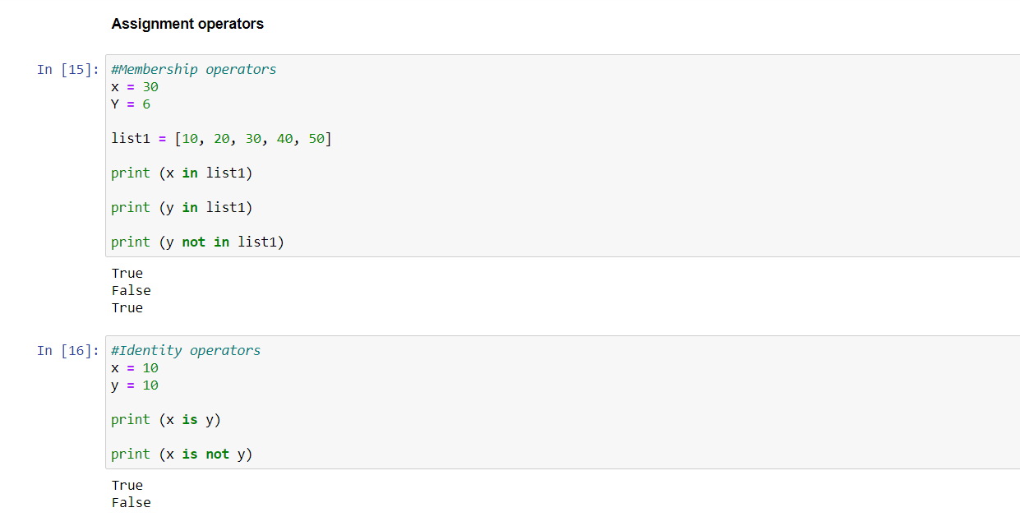

**Task-5**

**Task-** Solve the Tasks Sent by Ma’am: (OOP-Python)

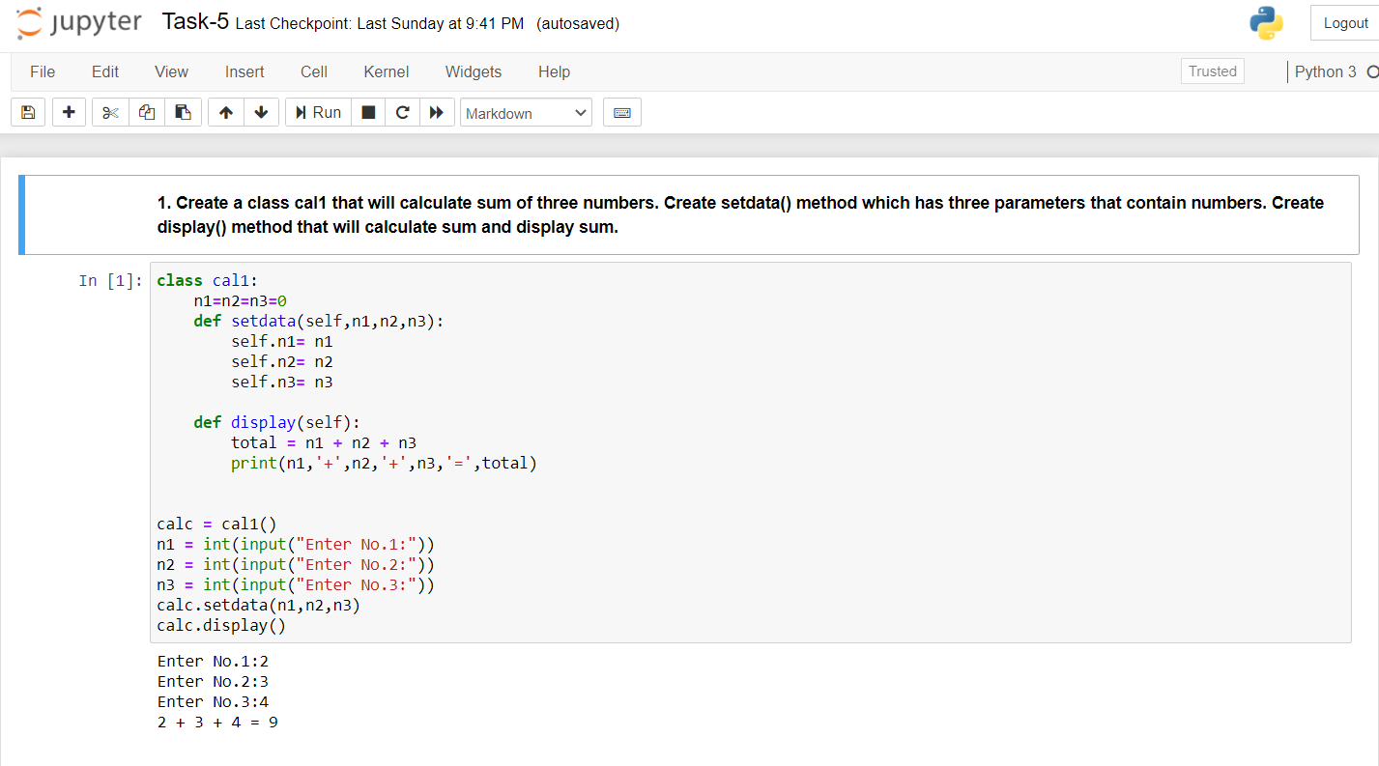

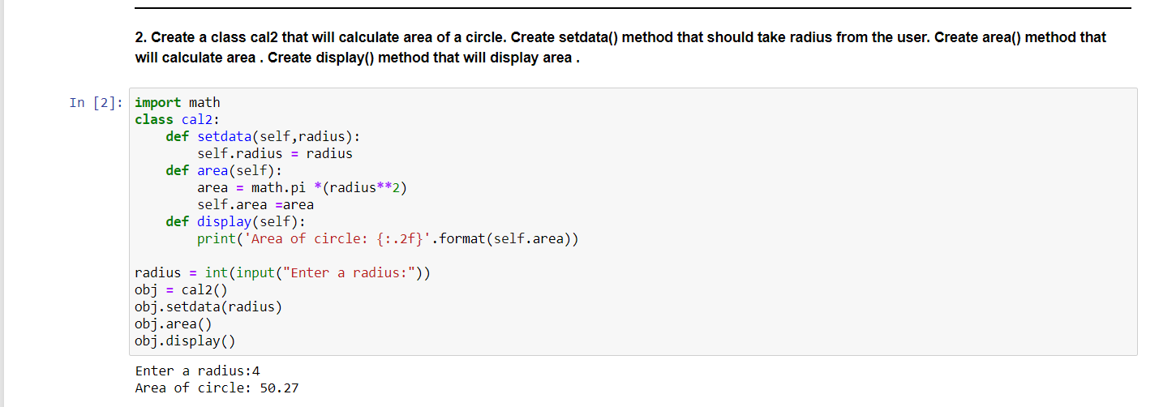

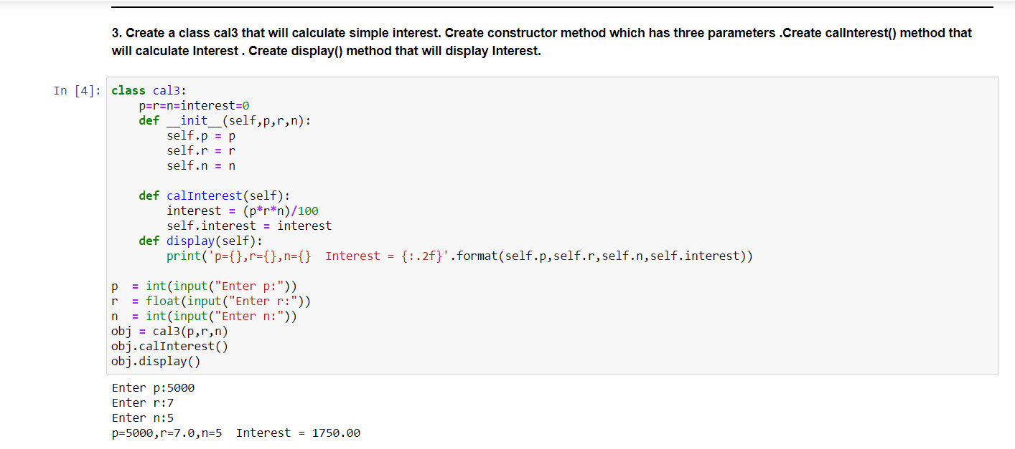

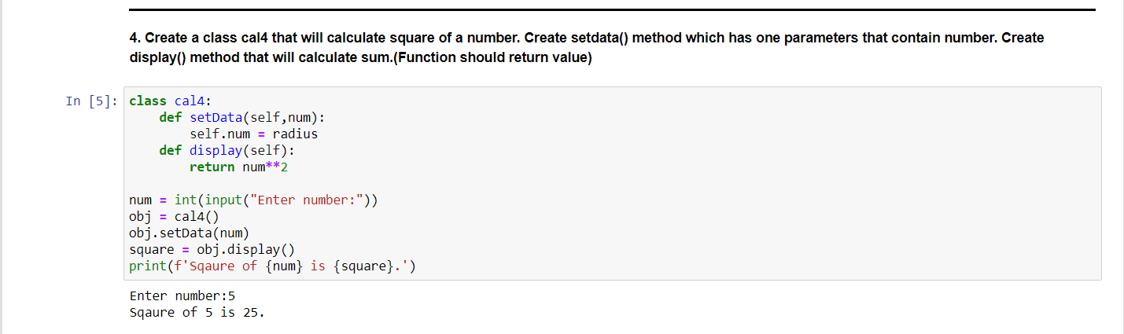

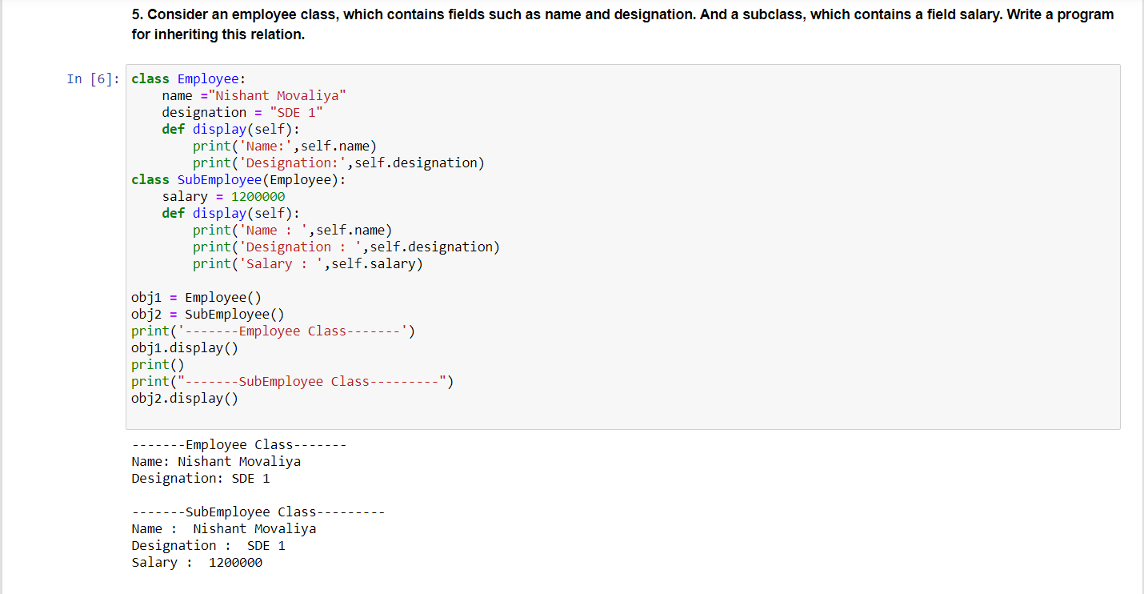

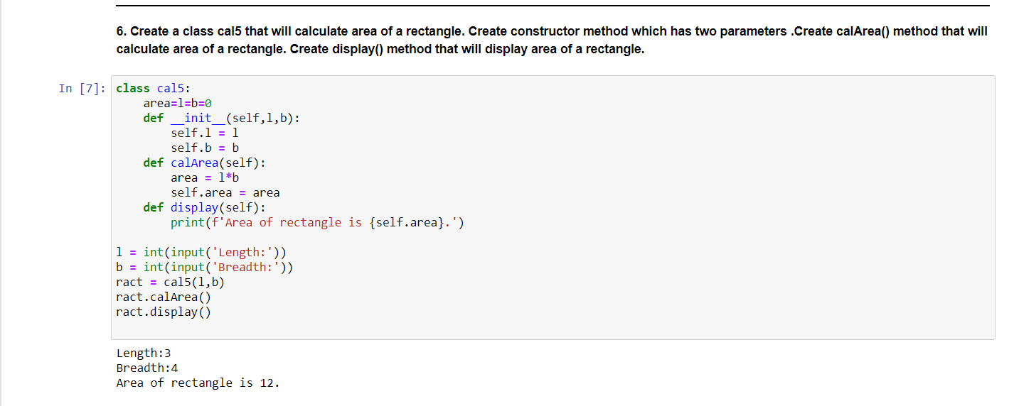

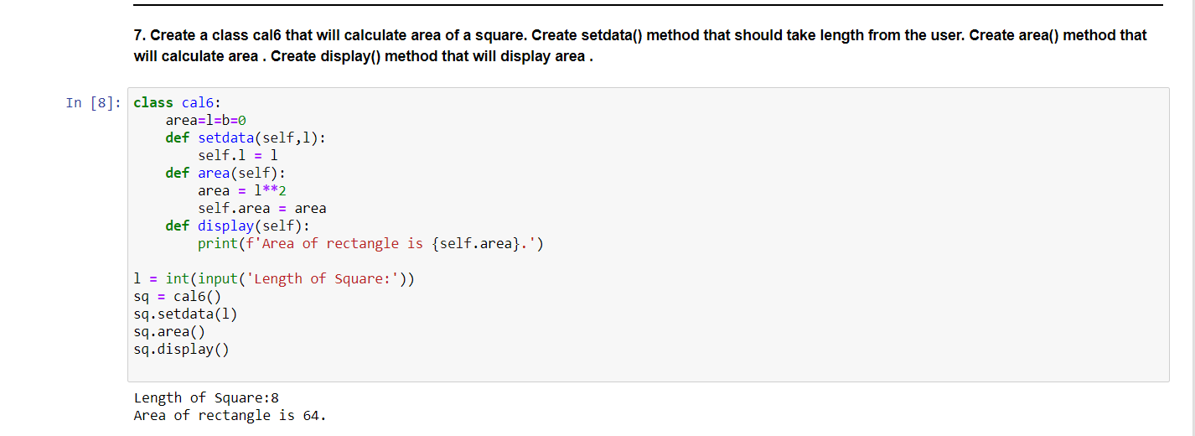

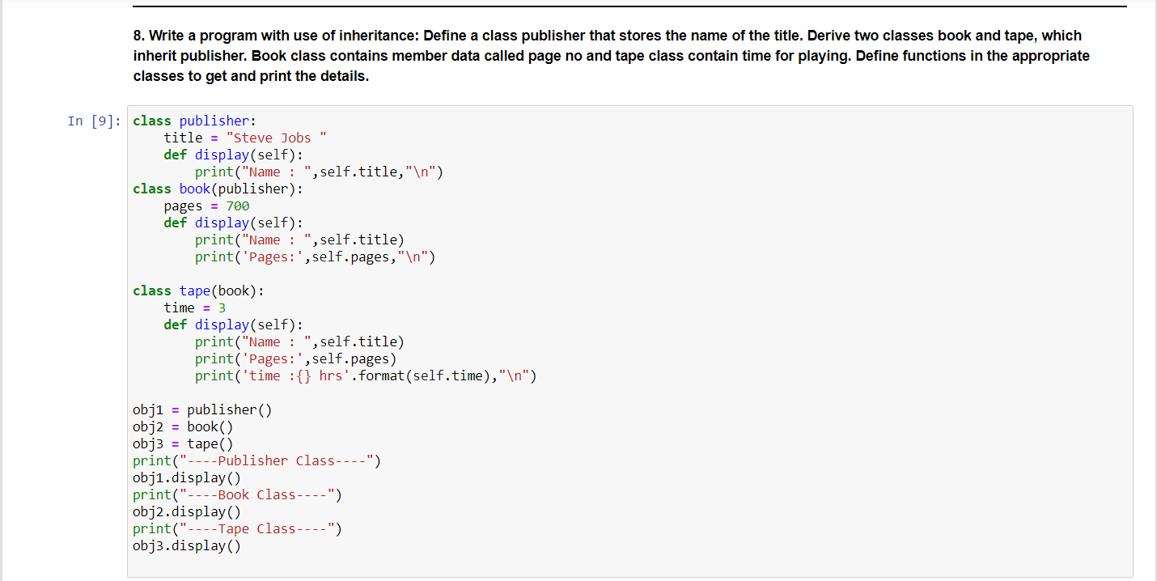

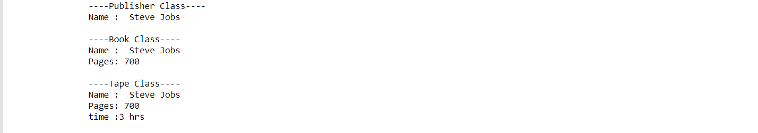 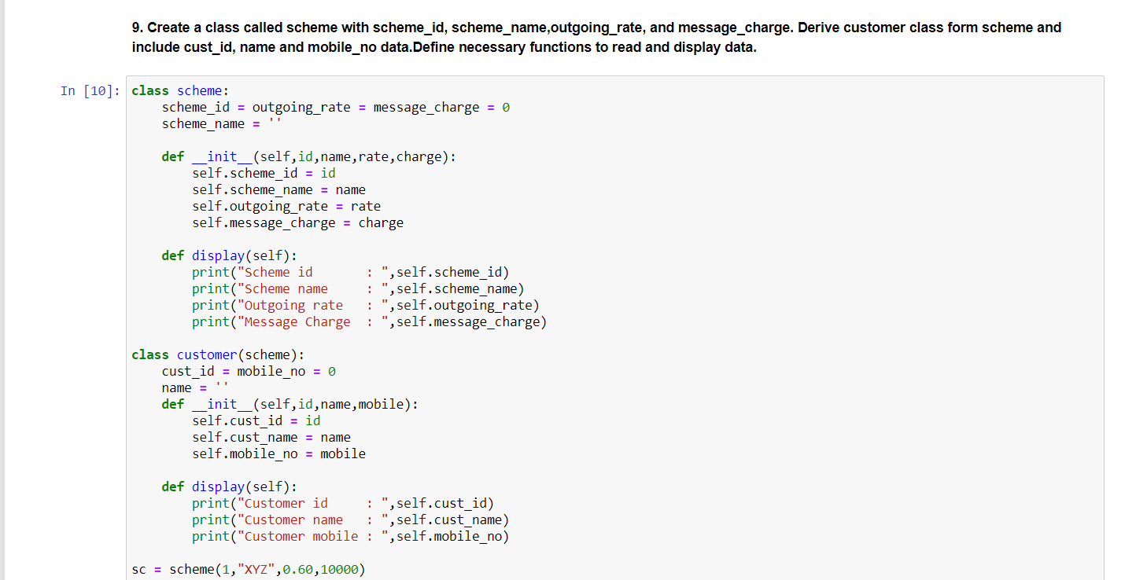

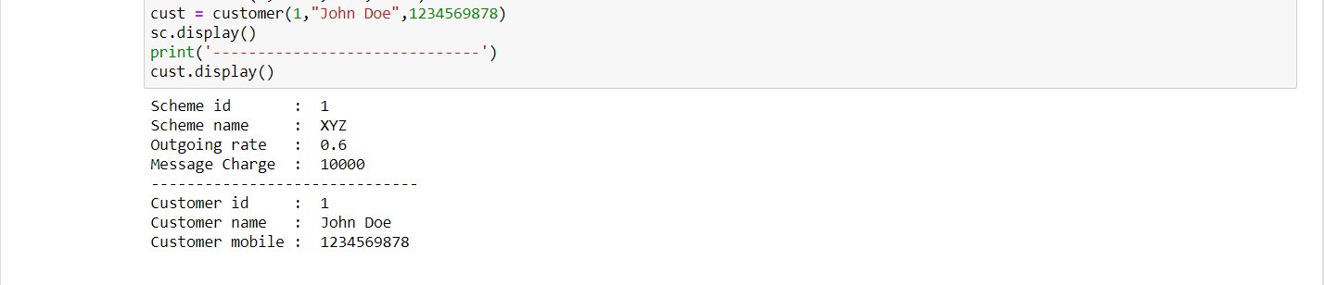

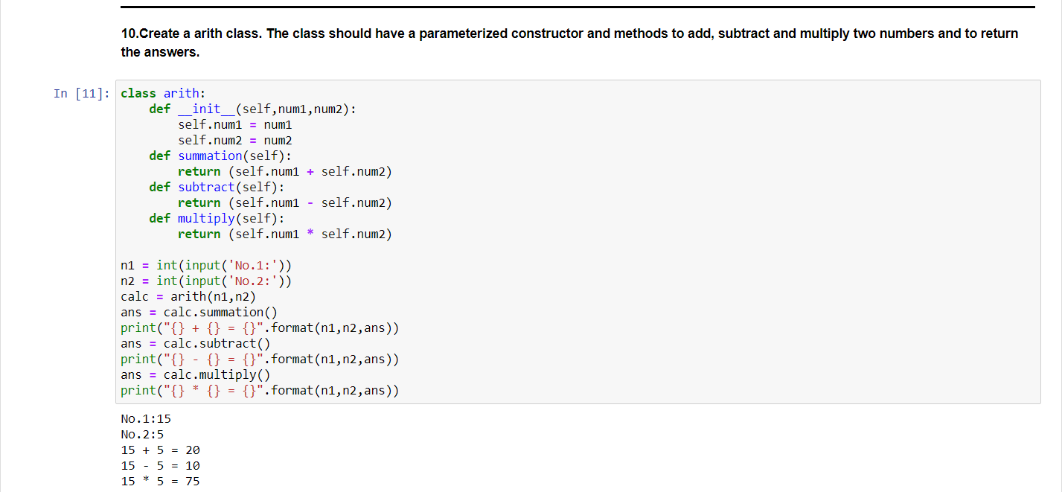

**Task-6**

Django Installation

Then create new project

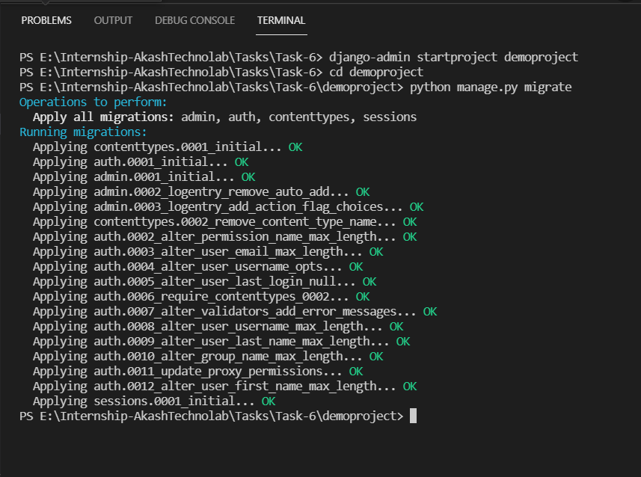

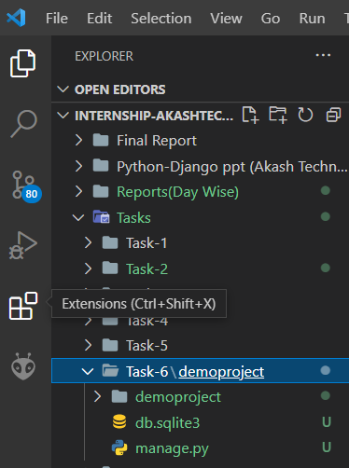

Necessary Command before running:

**Python manage.py runserver**

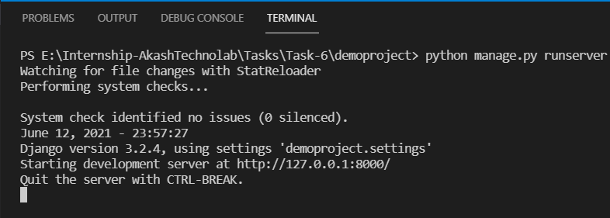

**Browser Window:**

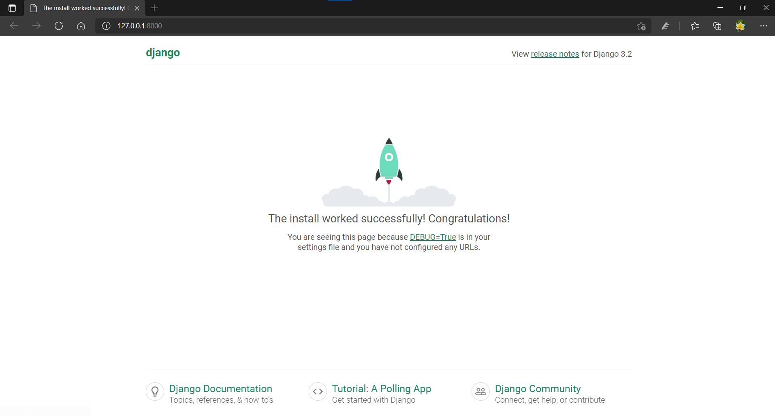

**Task-7**

After Creating Project and Creating an App, Make the following changes: INSTALLED_APPS in settings.py of Project1:

**views.py**

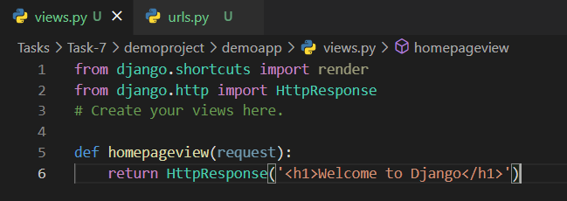

**urls.py**

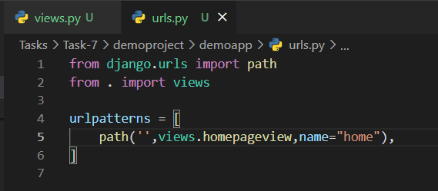

**demoproject/urls.py**

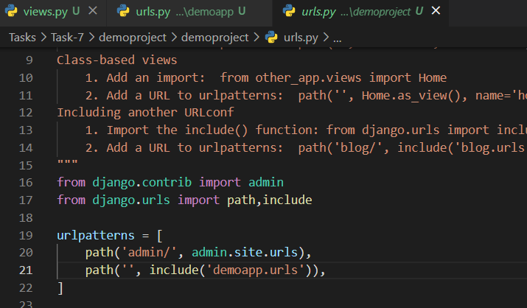

**Setting.py**

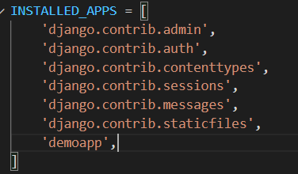

**Output:**

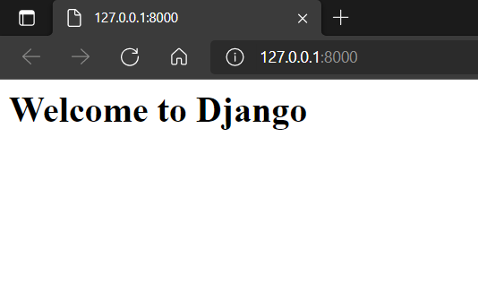

**Task-8**

**Code File:**base.html, index.html, about.html, contact.html

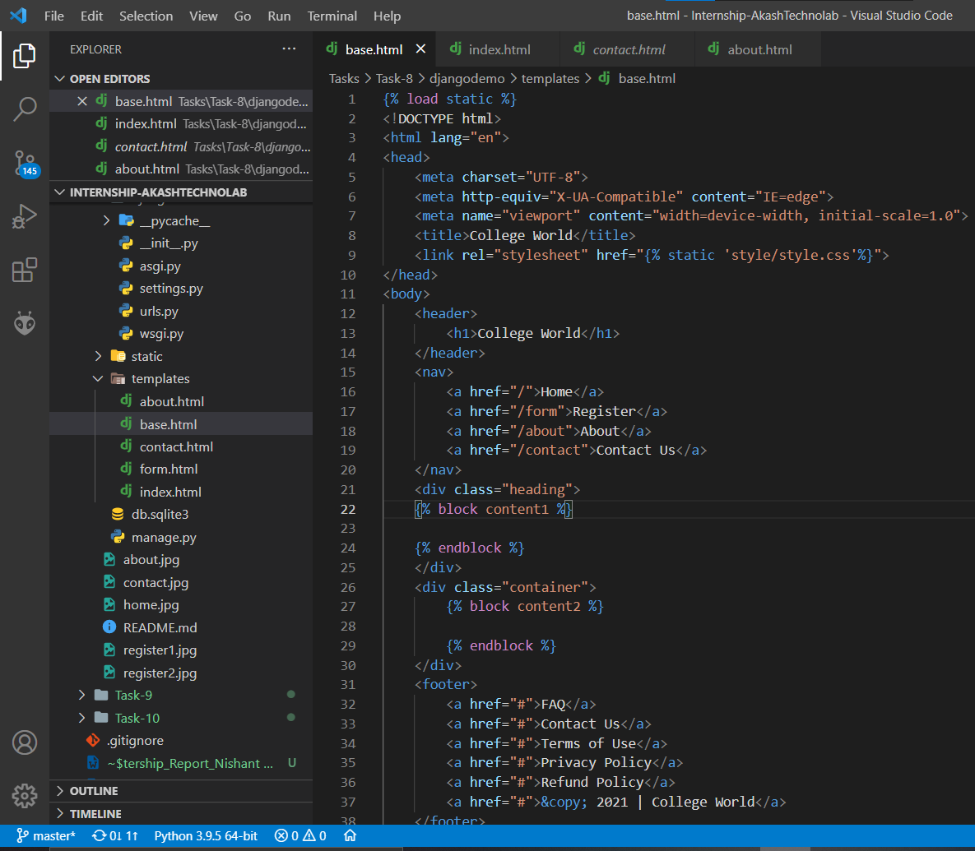

**Setting.py**

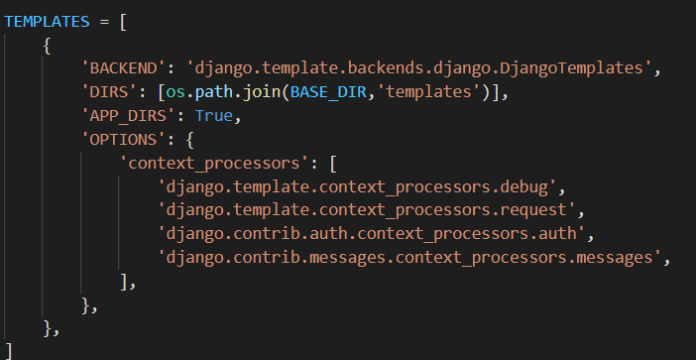

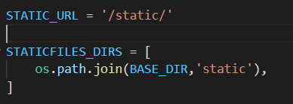

**index.html**

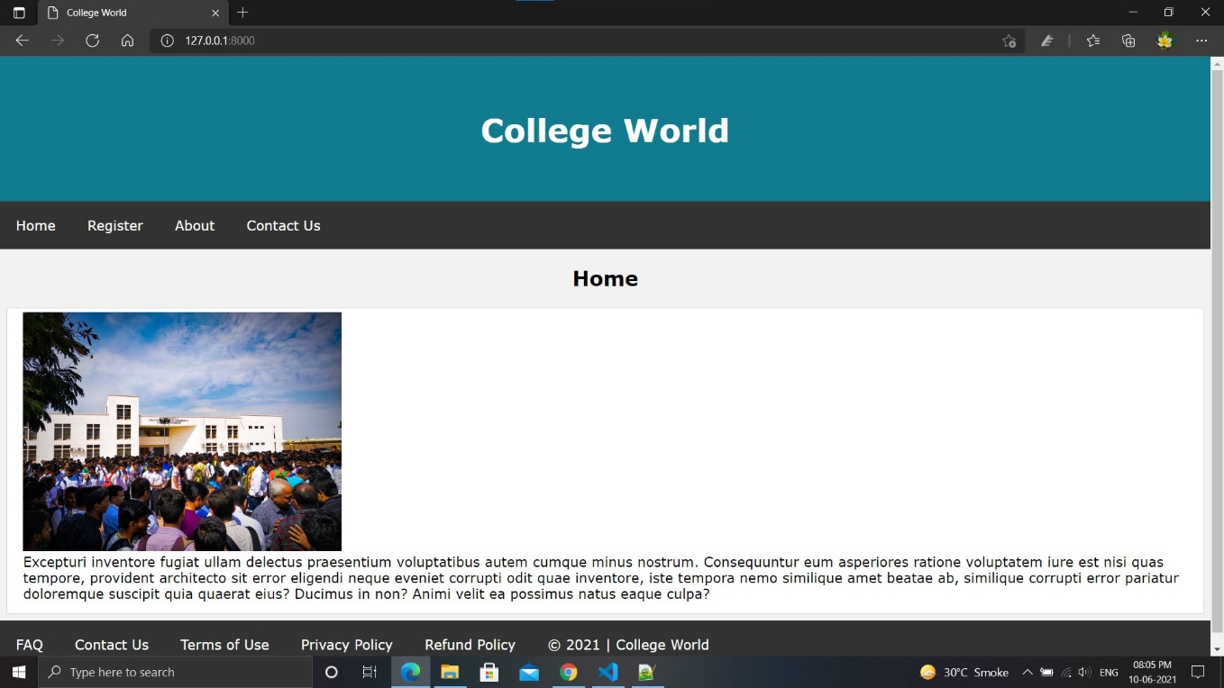

**about.html**

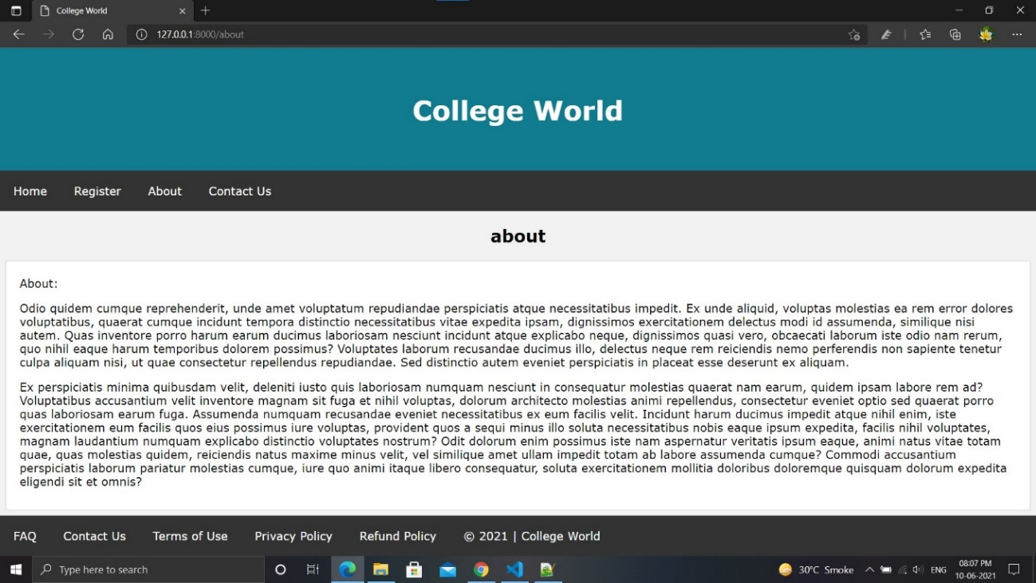

**contact.html**

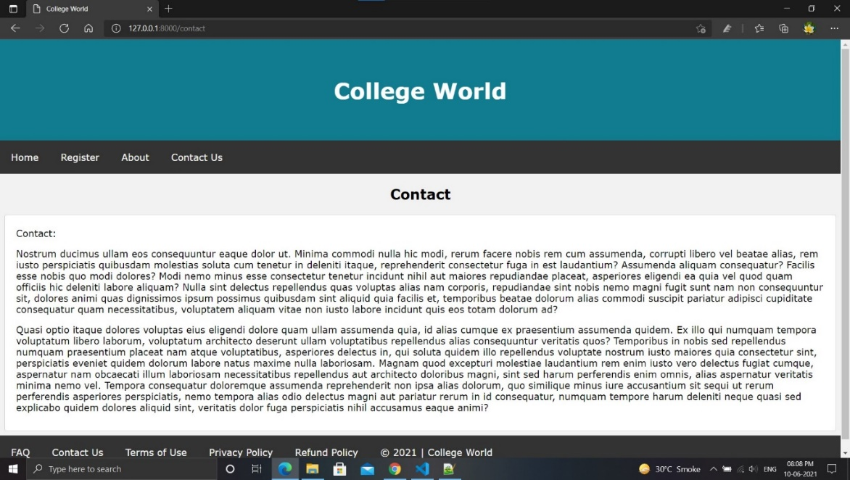

**Task-9**

**Task:** Using POST method to get User Values and returning back on page.

Here I’m going to extend the Project I did on Day 8

**signup.html**

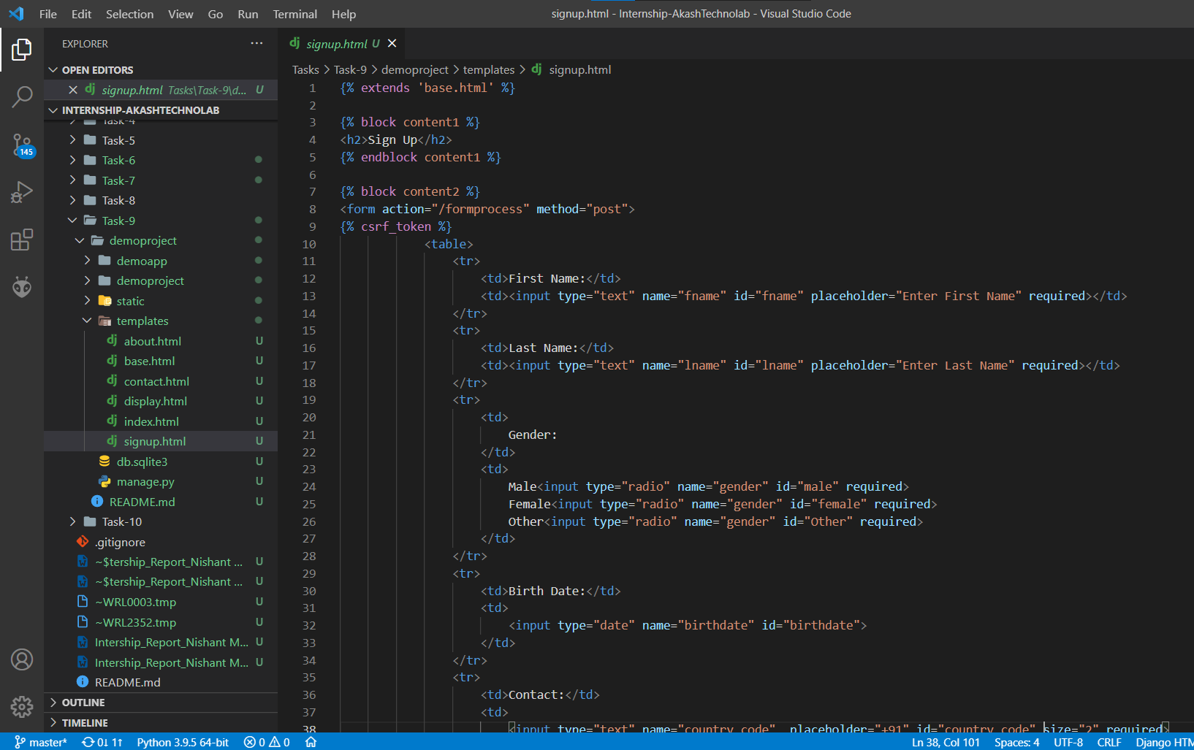

**views.py**

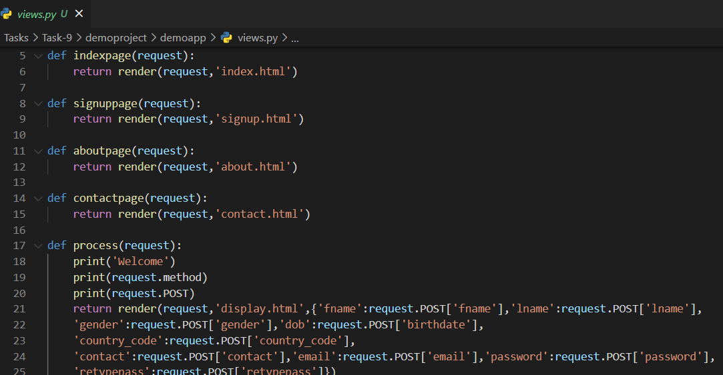

**display.html**

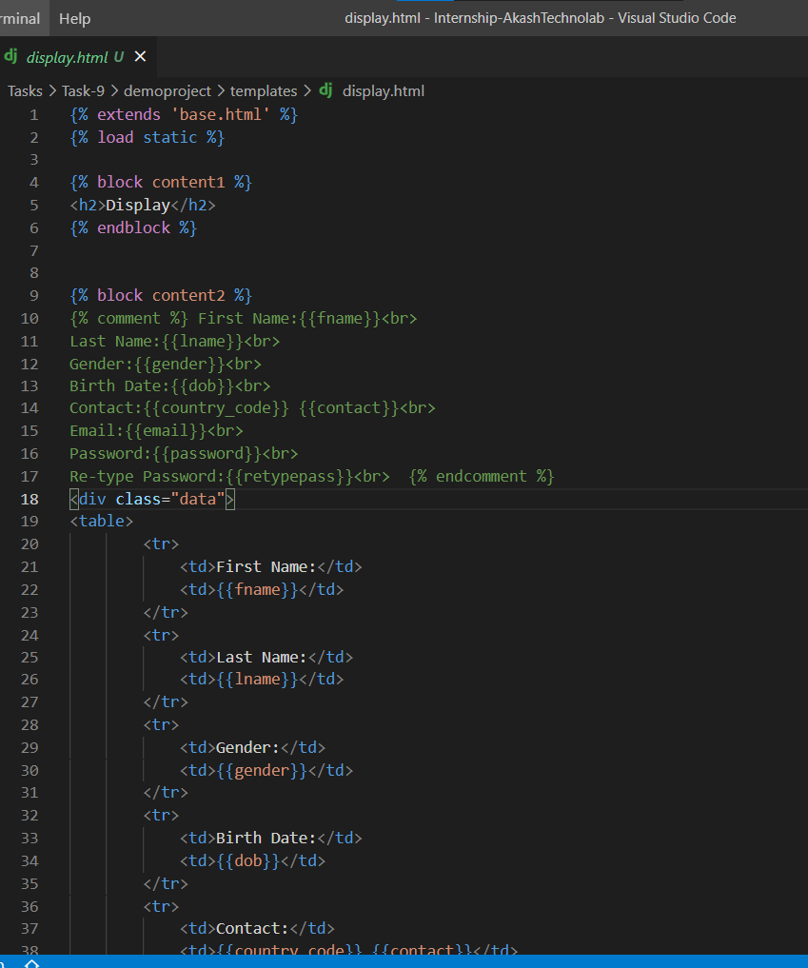

**Output:**

**Signup form:** signup.html

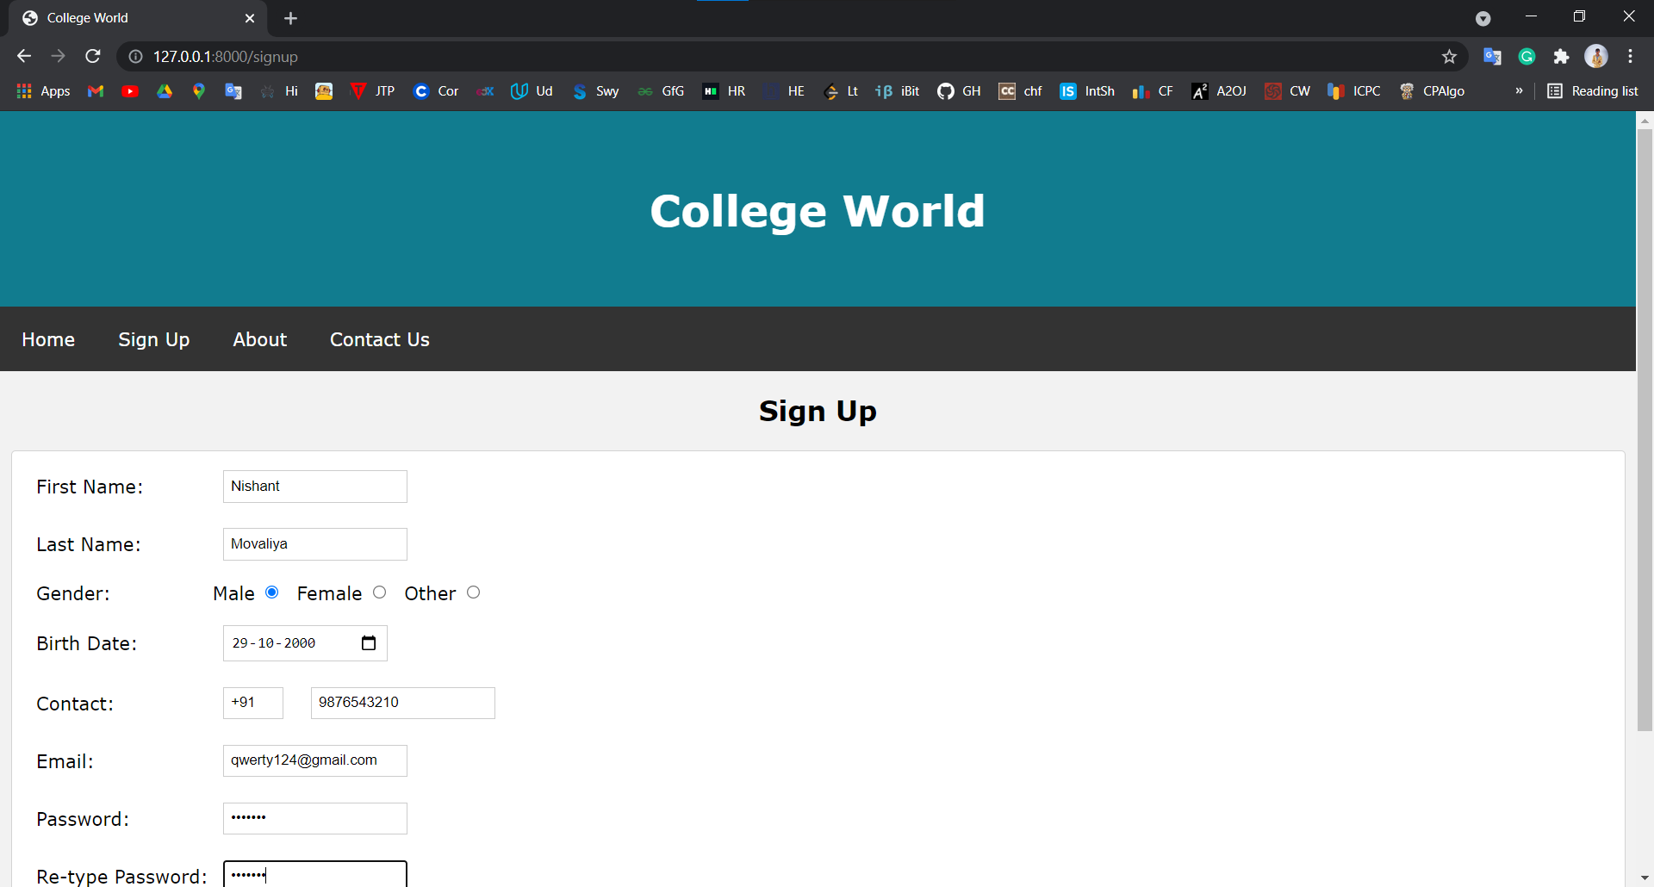

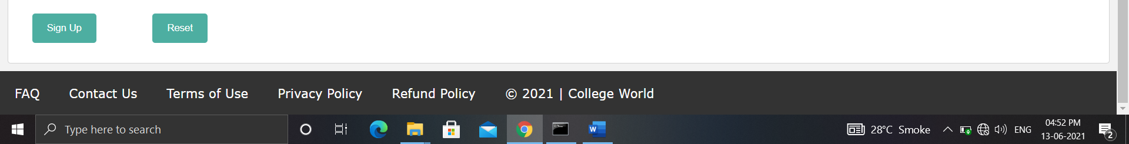

**display.html**

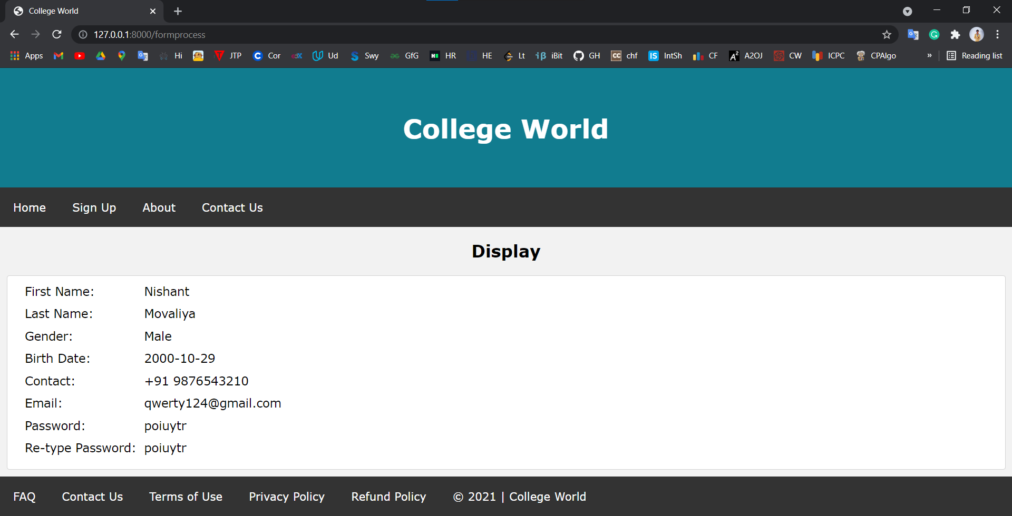

**Task-10**

**Task:**Implementing Models and Fetching Values using Function Based Views and Class Based Views

**views.py**

class based views:

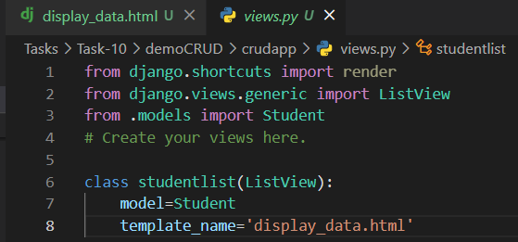

**models.py**

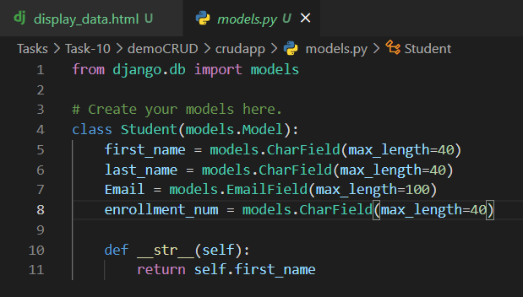

Registering Models in admin:

**admin.py**

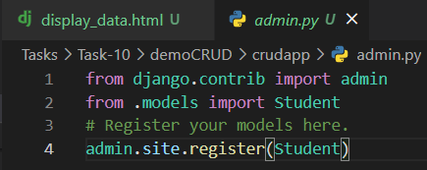

**views.py**

class based views:



**display_data.html**

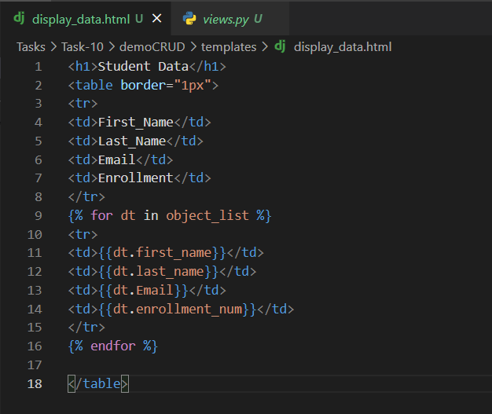

**Output:**



